To Drink or not To Drink

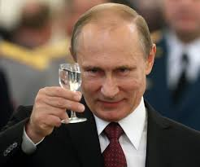

Russian alcohol consumption 2000-2016 and its impact on demographics and birthrate.

* The 2 datasets we are using:

<https://www.kaggle.com/dwdkills/alcohol-consumption-in-russia>

<https://www.kaggle.com/dwdkills/russian-demography>

* We would expect the life expectancy to increase as consumption increased
* We are going to extract CSV files into a comparative database such as SQL or Mongo